TestPilot Agent: Sanity Validation + Failure Log Analyzer (SVA-FLA Agent)

🔷 Problem
Modern CI/CD pipelines require fast validation + quick failure diagnosis, but:
- Smoke tests give only PASS/FAIL, not root cause
- Debugging failures is manual and time-consuming
- Lack of real-time failure insights
- Re-running tests requires manual effort
Enterprises face:
- Delayed release decisions
- High dependency on QA for debugging
- Repetitive failure analysis effort
- Limited visibility into why sanity failed

✅ Solution
A Unified AI Agent (SVA-FLA) that:
- Executes Sanity/Smoke tests (via Playwright MCP)
- On failure → Automatically analyzes logs
- Provides:
  - Root cause classification
  - Failure insights
  - Recommended fixes (NO auto-fix)
- Optionally triggers rerun of failed tests
👉 Acts as:
- Release gatekeeper
- AI-powered debugging assistant

🏗️ Architecture

CI/CD Trigger / Manual Run
↓
Sanity Agent (Playwright MCP)
↓
Test Execution (UI + API)
↓
PASS ------------------> Report Generated ✅
↓
FAIL
↓
Log Collection (trace, console, network)
↓
Failure Analyzer (LLM)
↓
Root Cause Classification
↓
Fix Suggestions (No auto-fix)
↓
Optional Rerun (last failed)
↓
Final Consolidated Report

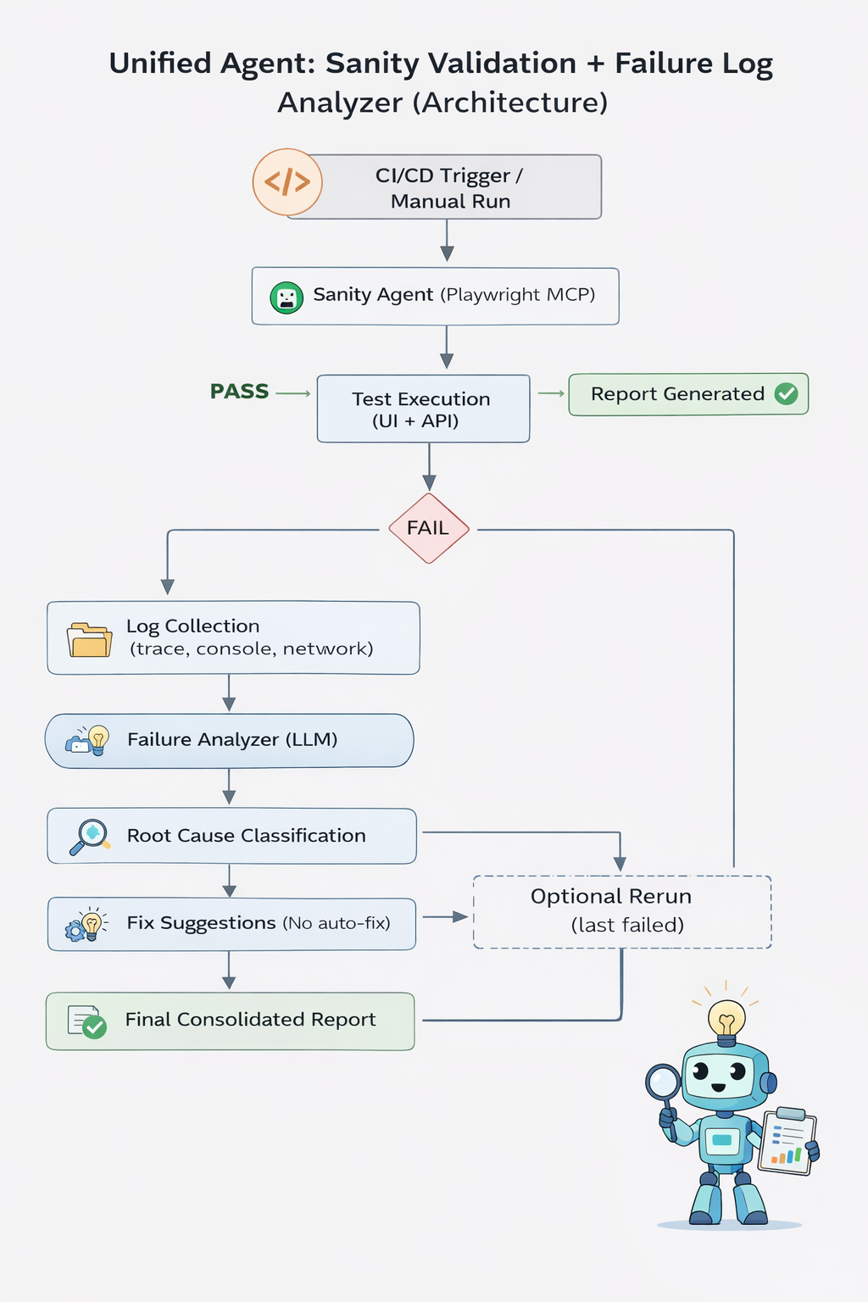

⚙️ Workflow

Step 1: Trigger
- Jenkins / GitHub Actions / Manual

Step 2: SanityAgent Execution
Agent executes:
- Login flow
- Homepage validation
- API health check
- Critical navigation flows

Step 3: Result Handling

✅ If PASS:
- Generate report

❌ If FAIL:

Step 4: Log Collection
Capture:
- Playwright trace.zip
- Console logs
- Network logs
- Screenshots

Step 5: AI Failure Analysis
Prompt Example:
Analyze the following test failure logs.

Classify into:
- Timeout
- Assertion failure
- API/Network issue
- Test data issue

Provide:
1. Root cause
2. Explanation
3. Suggested fix
4. Confidence level

Step 6: Output
Example:
Test: LoginTest
Status: FAILED

Root Cause: Locator Issue
Details: Element #login-btn not found
Suggestion: Use stable selector (data-testid)

Confidence: High

🔬 Feasibility
- Uses:
  - Playwright MCP (No-code execution)
  - LLM for analysis
- Integrates with:
  - CI/CD pipelines
  - Test reporting tools
- Minimal coding required (only orchestration layer)

📈 Viability
Reduces:
- Debugging time by 60%
- Release validation time by 50%
Improves:
- Faster go/no-go decisions
- Test failure transparency
- QA efficiency

💡 Desirability
- Developers get instant failure insights
- QA avoids repetitive debugging
- Managers get clear release status

🧩 Key Features Summary
Feature | Supported
No-code sanity execution | ✅
Failure log analysis | ✅
Root cause classification | ✅
Fix suggestions | ✅

🚀 End-to-End Flow
Code Commit
↓
CI/CD Trigger
↓
Sanity Agent (MCP)
↓
PASS → Release ✅
↓
FAIL
↓
Failure Analyzer
↓
Insights + Suggestions
↓
Rerun (optional)
↓
Final Report

